SQL:-

>Insert:

Syntax: INSERT TABLE ‘schema’.’table_name’ (colum_name1, column_name2......) VALUES (value1,value2.....);

>Alter:

Syntax: To add column:

ALTER TABLE schema.table_name ADD column_name data_type;

To modify column:

ALTER TABLE schema.table_name CHANGE COLUMN ‘column_name1’ ‘column_name2’ data_type;

>Filter Results with Where Statement:

Syntax: SELECT column1, column2, ... FROM table_name WHERE condition;

>Delete values in table:

Syntax: DELETE FROM ‘schema’.’table_name’ where (condition);

>ORDER BY: BY: This Clause is used to sort the records in ascending or descending order.

>GROUP BY: This Clause is used to collect data from multiple records and group the result by one or more column.

>INNER JOIN: Returns dataset that have matching values in both tables

>LEFT JOIN: Returns all records from the left table and matched records from the right table.

>RIGHT JOIN: Returns all records from the right table and matched records from the left table.

>CROSS/CARTESIAN JOIN: Cartesian product of all associated tables. The Cartesian product can be explained as all rows present in the first table multiplied by all rows present in the second table.

CODE 1:

CREATE DATABASE db3;

USE db3;

SHOW TABLES;

CREATE TABLE Student

( Student_ID VARCHAR(10),

Student_Name VARCHAR(20),

Address VARCHAR(20),

DOB DATE,

Department_ID VARCHAR(20));

/*Inserting Values in Table Student*/

INSERT INTO Student VALUES('01','Luk','north,Delhi','1999-12-31','DOO1');

INSERT INTO Student VALUES('02','Annie','kochi,Kerala','1998-03-17','DOO2');

INSERT INTO Student VALUES('03','Maria','xyz,UP','1999-10-13','DOO3');

INSERT INTO Student VALUES('04','Rahul','Bangalore,Karnataka','1998-12-14','DOO2');

INSERT INTO Student VALUES('05','Sarah','mysore,TamilNadu','1999-7-29','DOO1');

SELECT * FROM Student;

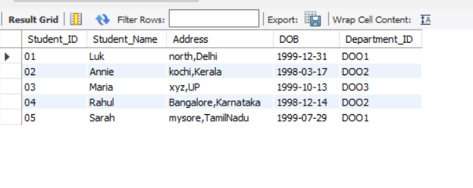

CREATE TABLE Subjects

( Subject_ID VARCHAR(10),

Subject_Name VARCHAR(20),

Lecturer_ID VARCHAR(20));

/*Inserting Values in Table Subjects*/

INSERT INTO Subjects VALUES('S01','Hindi','L1');

INSERT INTO Subjects VALUES('S01','English','L2');

INSERT INTO Subjects VALUES('S01','Arabi','L3');

INSERT INTO Subjects VALUES('S02','Chemistry','L4');

INSERT INTO Subjects VALUES('S02','Physics','L5');

INSERT INTO Subjects VALUES('S03','Probabilty','L6');

INSERT INTO Subjects VALUES('S03','Calculus','L7');

SELECT * FROM Subjects;

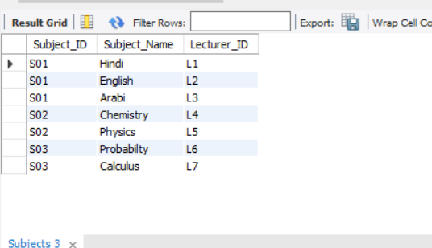

CREATE TABLE Lecturers (

Lecturer_ID VARCHAR(10),

Lecturer_Name VARCHAR(20),

Department_ID VARCHAR(20));

INSERT INTO Lecturers VALUES('L1','Maya','DOO1');

INSERT INTO Lecturers VALUES('L2','David','DOO1');

INSERT INTO Lecturers VALUES('L3','Rohit','DOO2');

INSERT INTO Lecturers VALUES('L4','Diya','DOO2');

INSERT INTO Lecturers VALUES('L5','Liya','DOO2');

INSERT INTO Lecturers VALUES('6','Sanya','DOO3');

INSERT INTO Lecturers VALUES('L7','Jake','DOO3');

SELECT * FROM Lecturers;

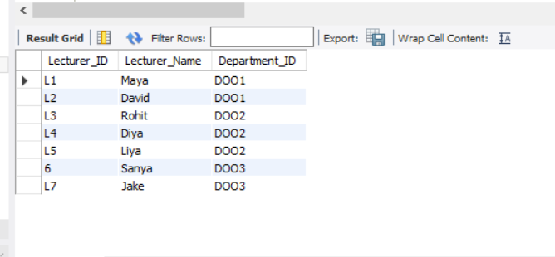

CREATE TABLE Departments (

Department_ID VARCHAR(10),

Department_Name VARCHAR(20));

INSERT INTO Departments VALUES('DOO1','Languages');

INSERT INTO Departments VALUES('DOO2','Science');

INSERT INTO Departments VALUES('DOO3','Maths');

/*Displaying Contents in Table Departments*/

SELECT * FROM Departments;

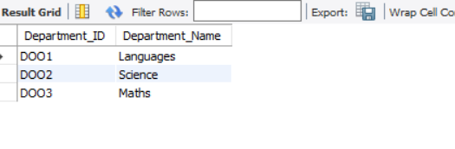

/*Creating Table FeeStructure*/

CREATE TABLE FeeStructure (

Student_ID VARCHAR(10),

Fee INTEGER);

/*Inserting Values in Table FeeStructures*/

INSERT INTO FeeStructure VALUES('O1',25000);

INSERT INTO FeeStructure VALUES('O2',25000);

INSERT INTO FeeStructure VALUES('O3',25000);

INSERT INTO FeeStructure VALUES('O4',25000);

INSERT INTO FeeStructure VALUES('O5',25000);

SELECT * FROM FeeStructure;

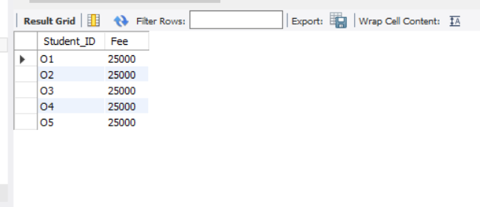

/*Using WHERE*/

SELECT * FROM Lecturers WHERE Department_ID = 'DOO2';

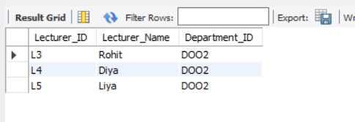

/*Using LIKE*/

SELECT * FROM Student WHERE Address LIKE '%,Delhi%';

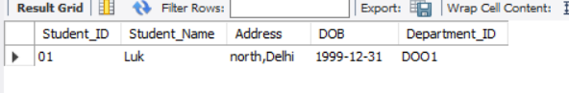

/*Using BETWEEN*/

SELECT * FROM Student WHERE DOB BETWEEN '1998-01-01' AND '1998-12-31';

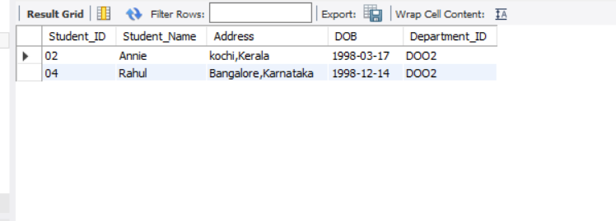

/*Using DISTINCT*/

SELECT DISTINCT Department_ID FROM Lecturers;

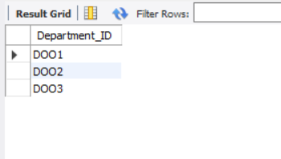

/*Using IN*/

SELECT * FROM Student WHERE Department_ID IN ('DOO1','DOO2');

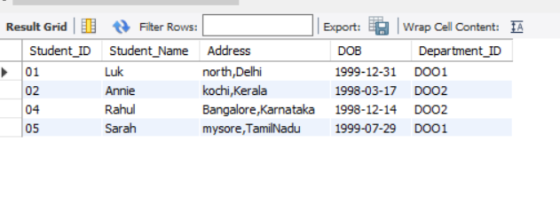

/*Using Having*/

SELECT * FROM Student GROUP BY Department_ID HAVING COUNT(Department_ID) <=1;

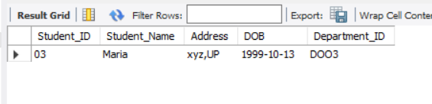

/*Using ALTER-ADD*/

ALTER TABLE Student ADD Email VARCHAR(20);

/*Using ALTER-DROP*/

ALTER TABLE Student DROP Email;

/*Using ALTER-MODIFY*/

ALTER TABLE Student MODIFY Department_ID VARCHAR(5);

/*Using Truncate*/

TRUNCATE TABLE FeeStructure;

SELECT * FROM FeeStructure;

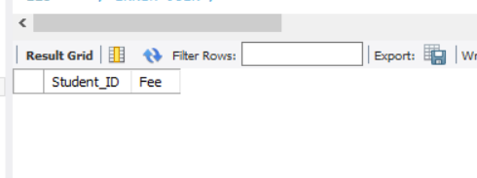

/*Joins*/

/*INNER JOIN*/

SELECT Lecturers.Lecturer_Name,Lecturers.Department_ID,Departments.Department_Name FROM Lecturers INNER JOIN Departments ON Lecturers.Department_ID=Departments.Department_ID;

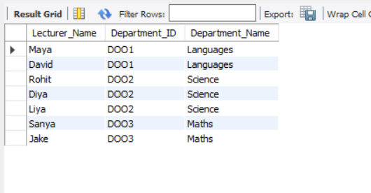

/*LEFT JOIN*/

SELECT Lecturers.Lecturer_Name,Lecturers.Department_ID,Departments.Department_Name FROM Lecturers LEFT JOIN Departments ON Lecturers.Department_ID=Departments.Department_ID ORDER BY Lecturers.Lecturer_Name;

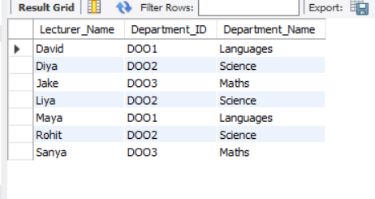

/*RIGHT JOIN*/

SELECT Lecturers.Lecturer_Name,Lecturers.Department_ID,Departments.Department_Name FROM Lecturers RIGHT JOIN Departments ON Lecturers.Department_ID=Departments.Department_ID ORDER BY Lecturers.Lecturer_Name;

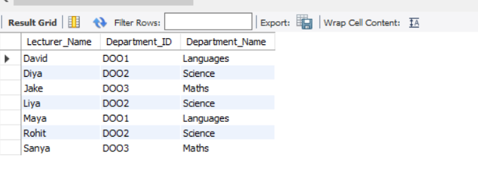

CODE 2:

use employeedatabase11;

show tables;

INSERT INTO `employeedatabase11`.`employee` (`Emp_ID`, `Emp_Name`, `Emp_Age`, `Emp_Dep`, `Dep_ID`, `Emp_Location`, `Emp_Salary`) VALUES ('101', 'Ravi', '32', 'HR', '111', 'Bangalore', '10000');

INSERT INTO `employeedatabase11`.`employee` (`Emp_ID`, `Emp_Name`, `Emp_Age`, `Emp_Dep`, `Dep_ID`, `Emp_Location`, `Emp_Salary`) VALUES ('102', 'Ishitha', '25', 'Sales', '113', 'Chennai', '15000');

INSERT INTO `employeedatabase11`.`employee` (`Emp_ID`, `Emp_Name`, `Emp_Age`, `Emp_Dep`, `Dep_ID`, `Emp_Location`, `Emp_Salary`) VALUES ('103', 'Rupa', '23', 'IT', '112', 'Hyderabad', '25000');

INSERT INTO `employeedatabase11`.`employee` (`Emp_ID`, `Emp_Name`, `Emp_Age`, `Emp_Dep`, `Dep_ID`, `Emp_Location`, `Emp_Salary`) VALUES ('104', 'Kiran', '27', 'Sales', '113', 'Raipur', '17500');

INSERT INTO `employeedatabase11`.`employee` (`Emp_ID`, `Emp_Name`, `Emp_Age`, `Emp_Dep`, `Dep_ID`, `Emp_Location`, `Emp_Salary`) VALUES ('105', 'Swetha', '20', 'HR', '111', 'Vizag', '22750');

INSERT INTO `employeedatabase11`.`employee` (`Emp_ID`, `Emp_Name`, `Emp_Age`, `Emp_Dep`, `Dep_ID`, `Emp_Location`, `Emp_Salary`) VALUES ('106', 'Pooja', '21', 'HR', '111', 'UP', '22000');

show tables;

select*from employee;

select Emp_Name,Emp_Age from employeedatabase11.employee where Emp_location='Raipur';

SELECT * FROM employeedatabase11.department;

DELETE FROM `employeedatabase11`.`department` WHERE (`Dep_No` = '117');

show tables;

select*from department;

select avg(Emp_Salary)AS Avg_Salary,Emp_Location from employeedatabase11.employee group by Emp_Location having Avg_Salary>18000 order by avg(avgEmp_Salary)desc;

select employee.Emp_Name,employee.Dep_ID,department.Dep_Name,department.Dep_Location

from employeedatabase11.employee

inner join employeedatabase11.department

on employee.Dep_ID=department.Dep_No;

select employee.Emp_Name,employee.Emp_Location,dependant.Dependent_Name,dependant.Dependant_Location

from employeedatabase11.employee

left join employeedatabase11.dependant

on employee.Emp_ID=dependent.E_ID;

select employee.Emp_Name,employee.Dep_ID,department.Dep_Location,department.Dep_Name

from employeedatabase11.employee

right join employeedatabase11.department

on employee.Dep_ID=department.Dep_No;

select*from employeedatabase11.department CROSS JOIN employeedatabase11 where Emp_Salary>17000

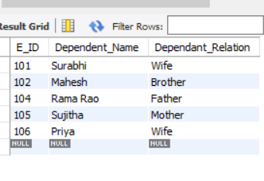

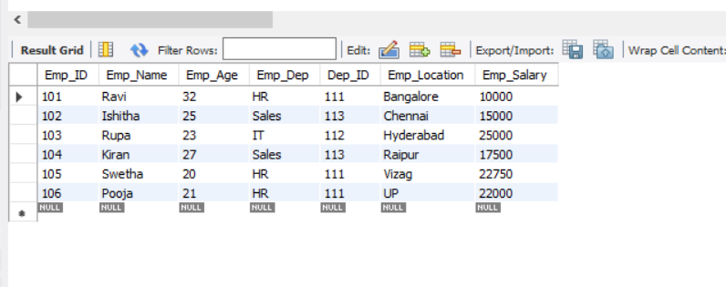

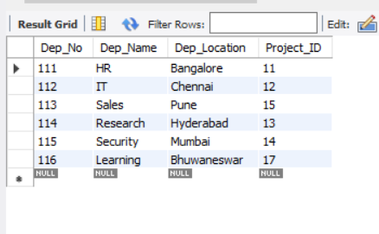

CODE 3:

create database db2;

use db2;

CREATE TABLE STATION(ID INTEGER PRIMARY KEY,CITY CHAR(20),STATE CHAR(2));

SHOW TABLES;

INSERT INTO STATION VALUES(13,'AGRA','AZ');

INSERT INTO STATION VALUES(23,'GOA','BZ');

SELECT*FROM STATION

